**Ministry of Education and Science of the Republic of Kazakhstan**

**Astana IT University**

**Report of the Project**

**“GENDER AND ETHNICITY AUTHENTICATION”**

**For course “Advanced Programming”**

**by Sultanmurat Yeleu**

**Made by: Aslanbek Mukhambetaliyev,**

**Daulet Toleugazy,**

**Ramazan Zainurainov**

**Group: IT-2204**

**Astana, 2024**

***Content of the Report***

**Introduction** **3**

1 Data and Methods 3

1.1 Dataset Description 3

1.2 Data Preprocessing 4

2 Model Processing 5

2.1 Architecture 5

2.2 Training Process 5

3 Results 6

4 Discussion 8

References for the Project9

**INTRODUCTION**

Authentication of a person's gender, and ethnicity based on facial images holds significant importance in various fields, including security, healthcare, and marketing. Leveraging advancements in machine learning and computer vision, this project aims to develop a robust model capable of accurately classifying gender and ethnicity from facial images.

Facial recognition technology has witnessed significant advancements in recent years, with applications ranging from identity verification to personalized user experiences. By analyzing facial features and patterns, machine learning models can infer essential attributes such as gender and ethnicity. These attributes play a crucial role in personalized services, targeted advertising, and demographic analysis.

The availability of large-scale datasets, such as the UTK dataset utilized in this project, facilitates the training of deep learning models for gender and ethnicity classification. However, challenges such as image quality, diversity, and biases must be addressed to ensure the model's reliability and fairness.

Through this project, we seek to explore the potential of machine learning in facial authentication while addressing practical considerations and ethical implications. By training and evaluating a convolutional neural network on the UTK dataset, we aim to contribute insights into the effectiveness and limitations of current facial recognition techniques.

1. **DATA AND METHODS**
   1. **DATASET DESCRIPTION**

The UTK Dataset is a crucial resource for our project, offering a diverse collection of 27,000+ facial images labeled with gender, and ethnicity. This dataset underwent meticulous curation and standardization, transitioning from raw JPEG files to a structured CSV format for easy integration into machine learning pipelines. Each dataset entry includes a facial image alongside gender and ethnicity categories.

Prior to model training, the dataset underwent thorough preprocessing to ensure consistency and quality. Image pixel values were standardized, and dimensions were uniformized to facilitate seamless integration into our machine learning pipeline. To facilitate collaborative development and seamless access to the dataset, we securely imported it into Google Drive. This enables efficient data management and sharing among project collaborators, fostering collaboration and facilitating experimentation with different model architectures and techniques.

The UTK dataset, coupled with Google Drive's accessibility and collaboration features, serves as the foundation for our project's exploration of facial authentication and demographic classification. By leveraging this comprehensive dataset, we aim to develop a robust and accurate model capable of authenticating a person's gender, and ethnicity based on facial images.

* 1. **DATA PREPROCESSING**

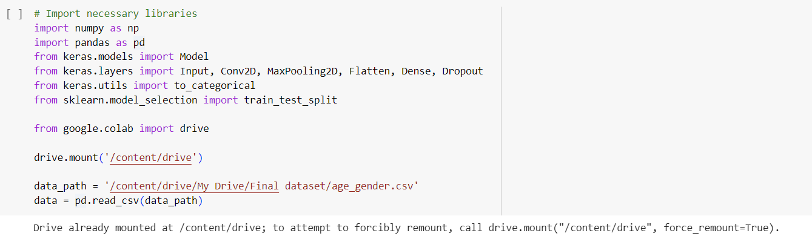

*Picture 1 - Adding Important Libraries to the Model*

*Picture 2 - Shaping Pixel Value Normalization*

In our project, we employed several preprocessing techniques to prepare the facial image dataset for classification:

* ***Loading and Formatting:***We initially loaded the dataset from Google Drive into Google Colab, leveraging its seamless integration with cloud storage for efficient data access and manipulation.
* ***Pixel Value Conversion:***The raw image data was transformed into NumPy arrays to facilitate efficient processing and manipulation within the machine learning framework.
* ***Image Reshaping:***To standardize the dimensions of the input images and ensure compatibility with the model architecture, we reshaped each image to a uniform size of 48x48x1.
* ***Pixel Value Normalization:***Normalization is a critical preprocessing step that enhances model performance and stability by scaling input features to a common range. In our case, we normalized the pixel values of the images to the range [0, 1].

1. **MODEL PROCESSING**

**2.1 ARCHITECTURE**

The model architecture is crucial for effective classification tasks. We designed a convolutional neural network (CNN) specifically for gender and ethnicity classification based on facial images, comprising the following key components:

* ***Convolutional Layers:*** Extract essential features and patterns from input images through convolutional operations, enabling the model to capture relevant information for classification.
* ***Max-Pooling Layers:*** Downsample feature maps, reducing computational complexity and enhancing model efficiency while preserving essential information.
* ***Flattening Layer:*** Transforms multi-dimensional feature maps into a flattened vector format suitable for input to dense layers, facilitating information flow and feature aggregation.
* ***Dense Layers:*** Perform high-level abstraction and classification using the flattened feature vector.
* ***Dropout Regularization:*** Mitigates overfitting by randomly deactivating neurons during training.

The integration of these components within the CNN architecture enables effective classification of gender and ethnicity based on facial images, highlighting the power and versatility of convolutional neural networks in facial authentication and demographic classification tasks.

**2.2 TRAINING PROCESS**

*Optimizer and Loss Function:* We trained the model using the *Adam* optimizer and categorical cross-entropy loss functions for both gender and ethnicity classification. Adam optimizes parameters efficiently, while categorical cross-entropy suits multi-class classification tasks well.

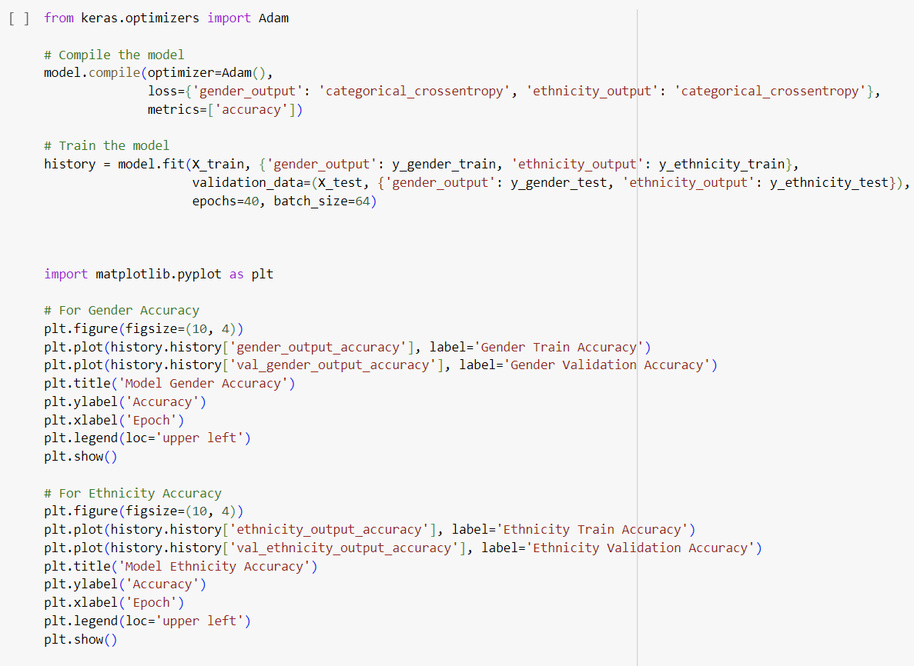

*Picture 3 – Compiling and Training Model*

***Training Parameters:***

* **Epochs:** 40
* **Batch Size:** 64

During training, batches of data were fed to the model, and parameters were optimized to minimize the loss function. The process iterated over multiple epochs, monitoring performance metrics like accuracy and loss. Following training, the model's performance was assessed on a validation dataset to gauge its generalization abilities and detect overfitting.

1. **RESULTS**

The model's performance on the validation set serves as a crucial indicator of its effectiveness in classifying gender and ethnicity based on facial images. We created the simple app for the project using Front-End tools with integrated Back-End structure with VS Code, and the results are the following:

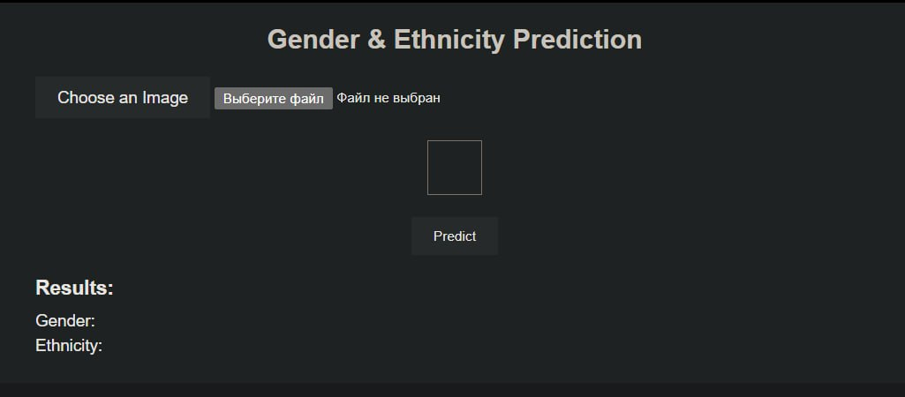

*Picture 4 – Main Interface of the App*

*Pictures 5,6 – Successful Cases of Identification*

Our model is able to recognize the gender and ethnicity of the person by picture using the main traits which were trained in our model, but because of the fact that traits can also fail in correctly identifying the person because of the unpredicted cases (such as lack or excess of light in the photo, non-common facial traits like make-up or accessories, etc.), there are cases of the imperfection of the app:

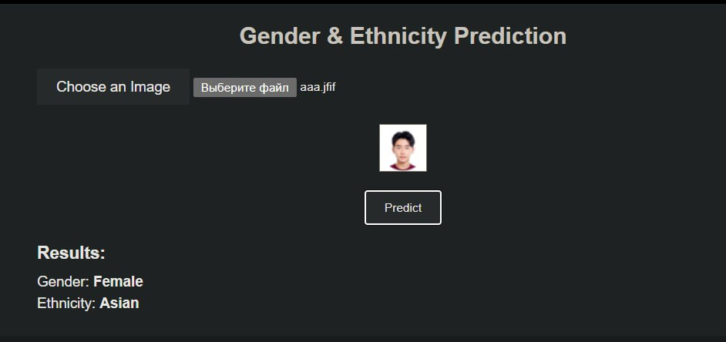

*Picture 7 – Fail in Identification*

1. **DISCUSSION**

***Critical Overview of Results:***

Despite achieving satisfactory accuracy for gender and ethnicity classification, our model exhibits certain limitations and areas for improvement. These limitations stem from factors such as image quality, dataset diversity, and inherent biases. The accuracy of the model may vary depending on the quality and diversity of the input images. Images with poor resolution or inconsistent lighting conditions may pose challenges for accurate classification. Enhancing image preprocessing techniques and incorporating diverse datasets could mitigate these issues. The model's performance may be influenced by biases present in the dataset, such as underrepresentation of certain ethnic groups or gender biases. Addressing these biases through balanced sampling strategies and bias mitigation techniques is crucial to ensure fair and unbiased model predictions.

***Next Steps:***

To overcome the identified limitations and further enhance the model's performance, several strategies and next steps can be pursued:

* *Data Augmentation:* Increase dataset diversity by employing data augmentation techniques such as rotation, flipping, and scaling. Augmented data can help the model generalize better to unseen variations in facial attributes and improve overall classification accuracy.
* *Model Optimization:* Fine-tune hyperparameters such as learning rate, batch size, and dropout rate to optimize the model's performance. Additionally, exploring different model architectures, including deeper networks or attention mechanisms, could yield improvements in classification accuracy.
* *Bias Mitigation:* Implement techniques to mitigate biases in the dataset and model predictions, such as fairness-aware training and adversarial debiasing. By addressing biases in the training data and model parameters, we can ensure more equitable and unbiased classification outcomes.

***Conclusion:***

In conclusion, this project underscores the potential of machine learning for authentication based on facial images. By training a convolutional neural network (CNN) on the UTK dataset, we successfully classified gender and ethnicity with reasonable accuracy. However, further improvements and research are necessary to address existing limitations and biases in the model. By adopting strategies such as data augmentation, model optimization, and bias mitigation, we can enhance the model's performance and ensure fair and unbiased classification outcomes. Ultimately, this project contributes to advancing the field of facial authentication and underscores the importance of rigorous evaluation and improvement strategies in machine learning applications.

***References for the Project:***

1. *Nipum, A. Age, Gender And Ethnicity (Face Data) CSV.* <https://www.kaggle.com/datasets/nipunarora8/age-gender-and-ethnicity-face-data-csv/data>
2. *Google Drive.* <https://drive.google.com/drive/folders/1dO2G-VW-6YBIjUEYtyWsF6DB0a-8-LRf?usp=share_link>
3. *Link to Video on YouTube.* <https://youtu.be/VHLMMHrm5MQ>